**Margin Analysis of “Alpha Mart”**

**A Proposal report for the BDM capstone**

**(Mid-Term Submission)**

**Project** Submitted by

Name: **Vimal Kumar**

Roll number: **22ds1000184**



IITM Online BS Degree Program,

Indian Institute of Technology, Madras, Chennai Tamil Nadu, India, 600036

Table of Contents

1. Executive Summary 3

2. Proof of Originality of the Data 3

3. Metadata and descriptive statistics 5

3.1 Detailed Explanation of Analysis Process/Method 7

3.2 Exploratory Data Analysis, Visualization and Analytics 7

4. Results and Findings 12

### 

## Executive Summary

The project titled "Margin Analysis of Alpha Mart", goal for mid-term is to analyze the sales data of a small grocery store, Alpha Mart, located in Begusarai, Bihar. The primary objective is to identify avenues for maximizing profitability and overall sales margin, in order to support the store owner's goal of expanding the business by opening additional outlets.

As stated in the proposal document, Alpha Mart is a medium size Grocery/Kirana store and even store is meeting good sales number, it is encountering challenges in terms of profitability. Adding to it, with rise of online shopping and stiff competition with other retailers, it is becoming quite challenging to maintain good net profit margin and work towards goal of expanding the store chain.

As part of this project, we will be employing various analytical techniques, including but not limited to identifying top-selling and most profitable products, analyzing customer purchase patterns. Through this extensive data analysis, we aim to provide practical solutions to overcome the prevalent issue and suggest avenues to improve net profit margin.

## Proof of Originality of the Data

**Details:**

Store Name: Alpha Mart

Owner: Mr. Navneet Kumar

Address: Sahjanand Nagar Rd, Shajanand Nagar, Bishanpur, Hemra, Begusarai, Bihar 851101

**About Organization:**

Alpha Mart is a small grocery store located in Begusarai, Bihar, India, operating as a B2C business. The store was established on April 17, 2022, with the aim of catering to the grocery and everyday household needs of the local community. Under the management of Mr. Navneet Kumar, the store's proprietor, Alpha Mart has been steadily growing its product range, currently offering over 2,500 items, ranging from everyday essentials to premium products. Over time, this store has become the go-to store for bulk purchase, party orders, at competitive price with utmost efficiency, customer satisfaction.

To substantiate my claims regarding originality of data collection from Alpha Mart, I have included multiple images/videos of institution itself, sample bills, billing system, data records.

Store’s picture

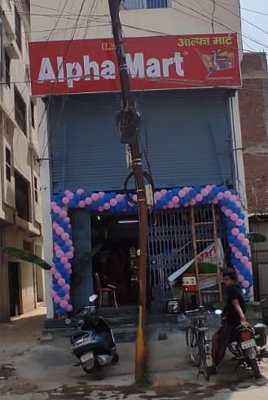 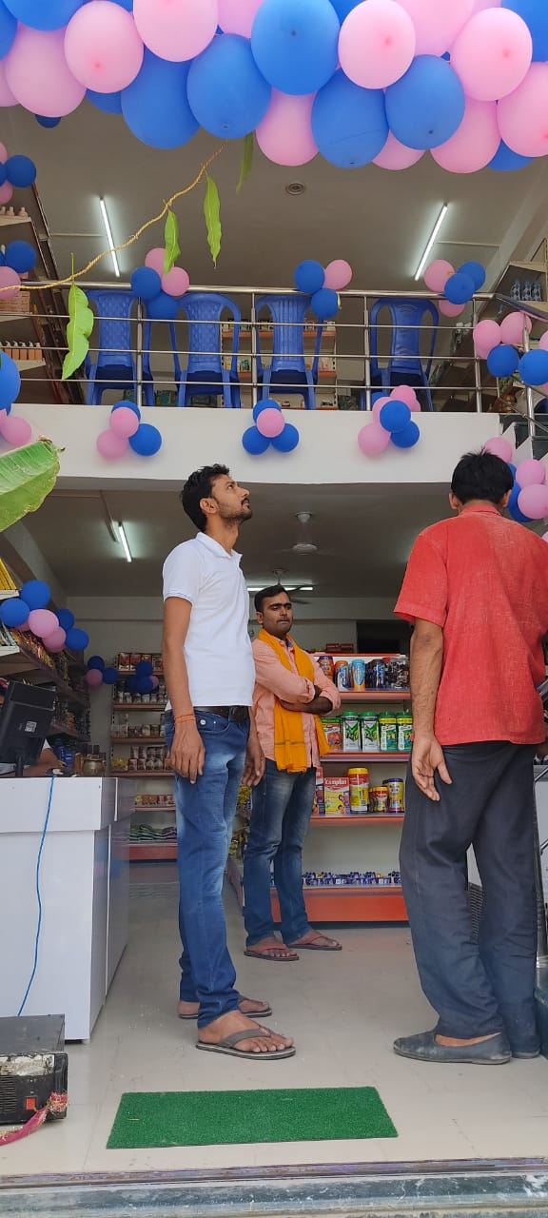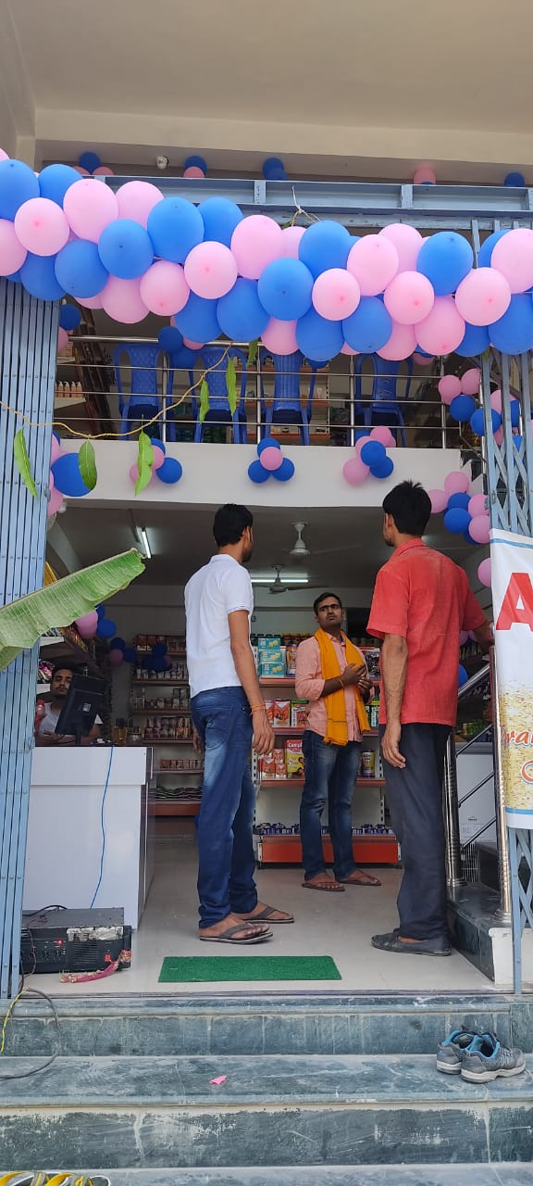

Store use “ABC billings” (name changed as per request from Shop owner) for generating automated bill cum invoice generation. It also maintains list of most (>96%) of the product sold with their brand details and Cost/purchase price and listed MRP. Some of the dairy products like Milk Bread, some local vendor biscuits etc, are not their billing system and is marked out of scope for this analysis.

Sample Bill generated at store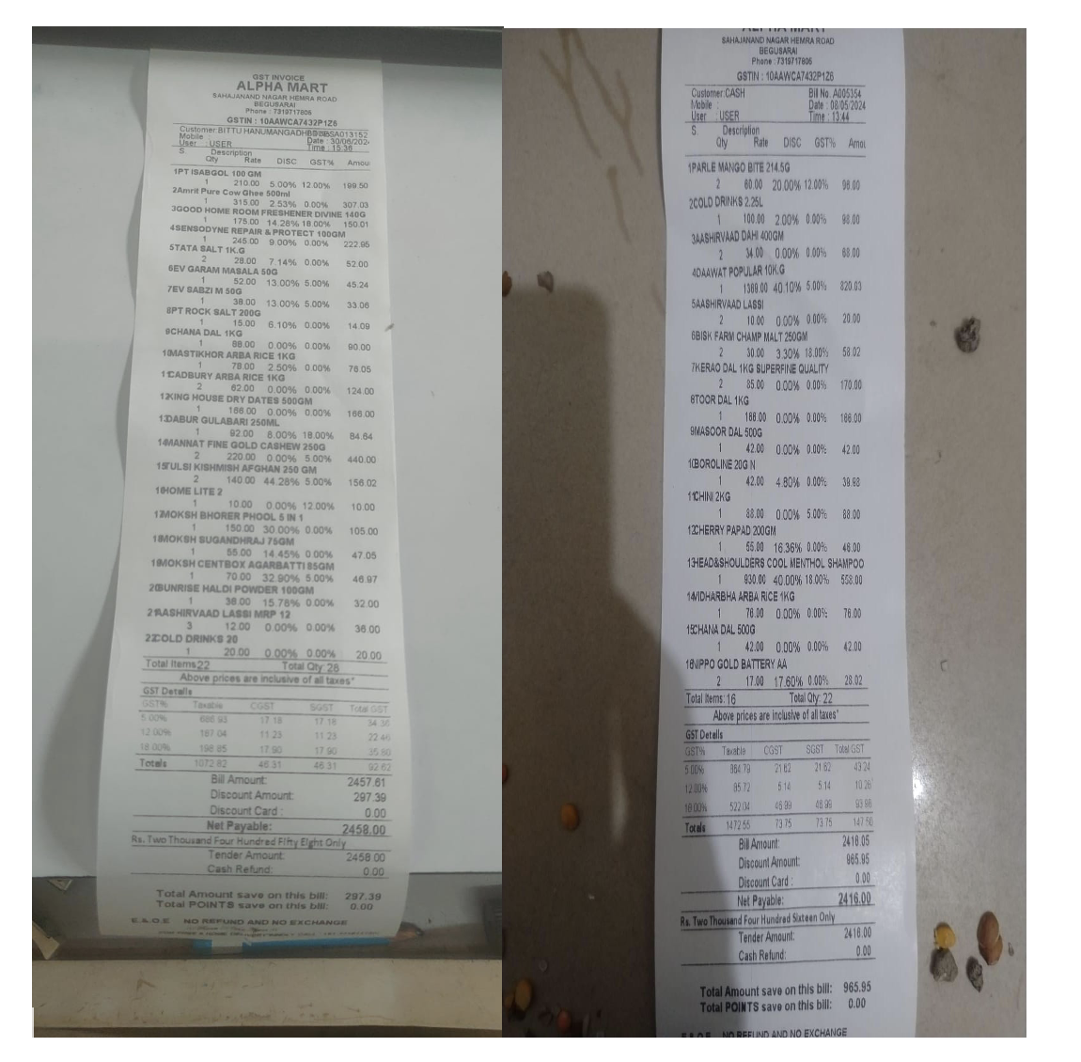

Store’s billing screen

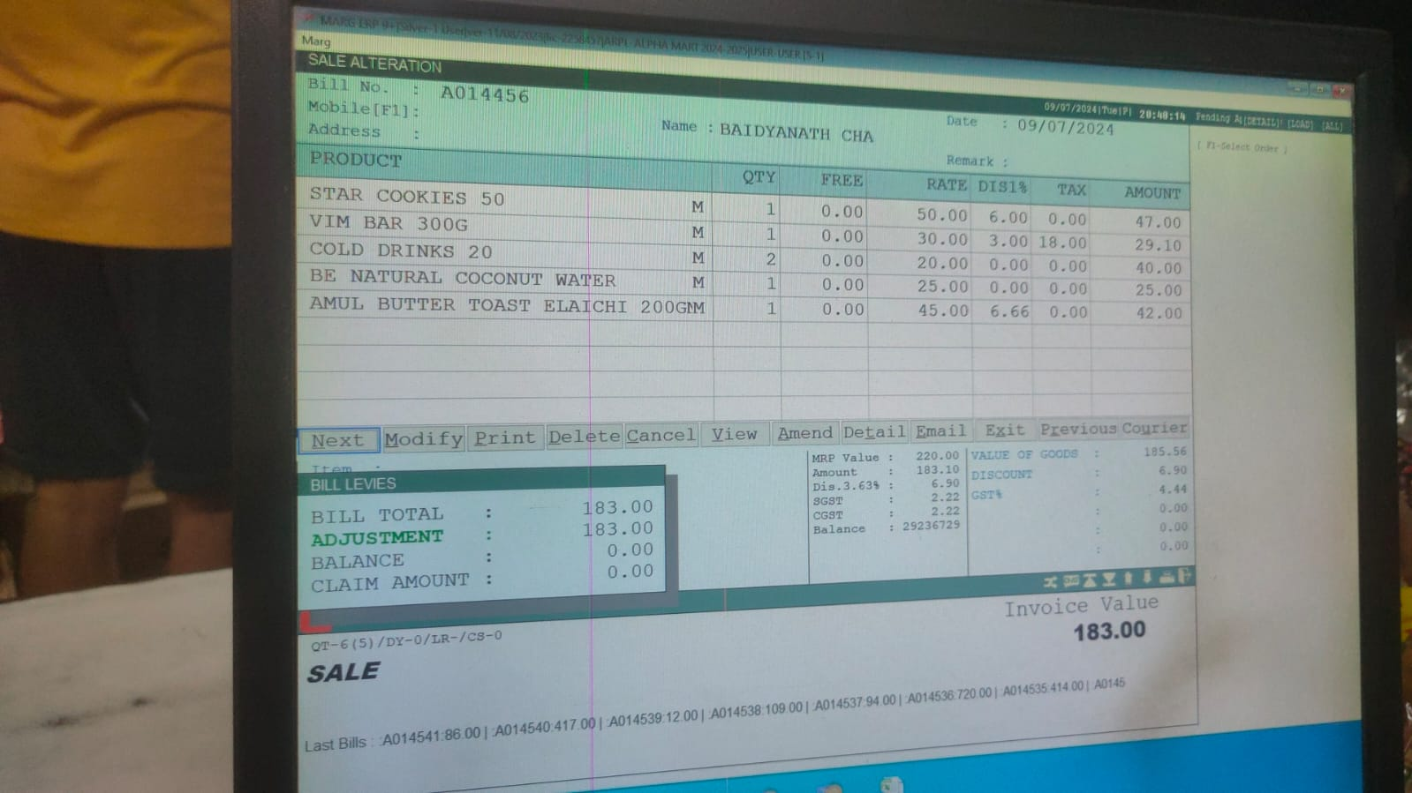

Drive link with all data, images, analysis: <https://drive.google.com/drive/folders/1FgH8RvF3rxsSqQ6iTecI0iOiGYipOc51?usp=sharing>

We also interacted with Store owner and added interaction video link:

<https://drive.google.com/file/d/11TzWwgKmv72hGvp0dP3YDh3ikat09eID/view?usp=drive_link>

## Metadata and descriptive statistics

As part of this project, extensive data analysis was performed on two datasets shared by Alpha Mart.

* *Stock Dump as of May 2, 2024*:

This dataset includes information on cost prices, purchase prices, discounts, selling prices, and maximum retail prices (MRP) for each product, enabling detailed profitability analysis.

* This file holds all the products sold by **Alpha Mart** along with their Current Stock, MRP, Purchase price, cost price and barcode details.
* Though, owner shared file is named “Stock Dump”, after reviewing the file – inventory information didn’t seem up to date. Most of the value in these columns were either zero or negative, and didn’t seem of much use.
* Metadata -
  + 2683 Rows
  + Columns Used:

*'Code'* : Unique Numeric internal number assigned to each product

*'Product Name'* : Name of Product

*'Unit'* : Unit of measure like Pcs (pieces)

*'Cost Price'* : This total cost to store for the product, including re-packaging cost, transportation cost, any sales commission

*'M.R.P.'* : Listed MRP for product *'Purchase Price'* : Actual purchase price from distributor/wholesaler

*'Sales Price'* : Sale price of product after default discount.

*'Company'* : Company of product ( ‘-BLANK-‘ are self-branded/packaged product created at store)

*'Manufacturer'* : All Blank

* Current Stock column doesn’t seem to have accurate values and thus not able to perform inventory analysis. Excluded columns :

*'Current Stock', 'Sales Scheme','Unnamed: 5',  'Purc.Scheme',  'Unnamed: 7',  'Rack No.','Barcode'*

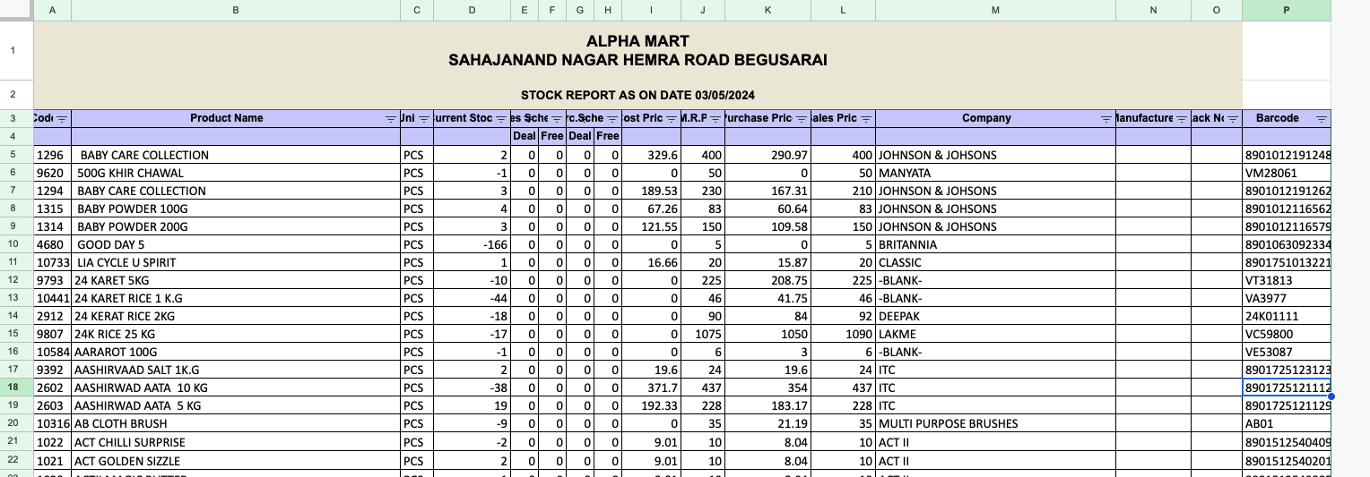

* NULL Check –

Unique values in Code: 2683

Unique values in Product Name: 2681

Unique values in Unit: 5

Unique values in Current Stock: 219

Unique values in Cost Price: 1593

Unique values in M.R.P.: 338

Unique values in Purchase Price: 1541

Unique values in Sales Price: 342

Unique values in Company: 212

* *Gross Sales Transactions for February, March, and April 2024*:

This dataset comprises approximately 26,000 records of individual sales transactions, providing insights into customer purchasing patterns, product demand, and revenue generation.

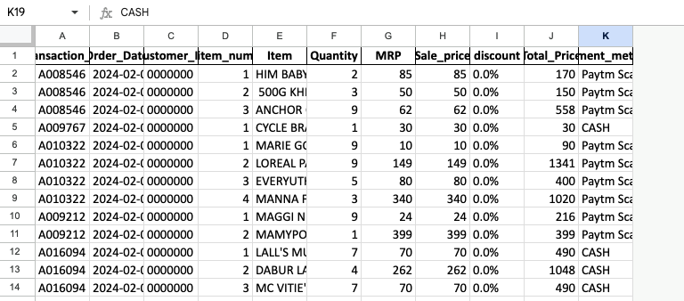

grocery_sales_feb_Mar_Apr_2024.xlsx

* This file holds all transactional details by **Alpha Mart** for the three month time period (Feb/March/April 2024).
* Metadata -
  + 26822 Rows
  + Columns :

'Transaction_ID', 'Order_Date', 'Customer_ID',

'item_num', 'item_code', 'Item', 'Quantity',

'MRP', 'Sale_price', 'discount',

'Total_Price', 'Payment_method'

* + Customer details are not captured by billing system. Rest all columns are usual and self-explanatory.

### 3.1 Detailed Explanation of Analysis Process/Method

From store owner, we received 2 files – one with product details and other with 3 months of sales transaction data. We used first file to fetch Company name of the product sold, Cost/Purchase price and MRP details. Further this file was used in conjunction with following *Sales_Txn* file for complete analysis.

Detailed data analysis was performed using Google Colab notebook. Results and supporting file are shared for review.

<https://drive.google.com/drive/folders/1FgH8RvF3rxsSqQ6iTecI0iOiGYipOc51?usp=sharing>

At first, the data from both the sheets was carefully examined to ensure its structure and format were clean and organized for effective analysis. This step involved checking for missing/NULL values and outliers that could impact the results. Also, a variety of descriptive statistical techniques (such as mean, average, profit) were applied to summarize and explore the data. Different visualization techniques like Charts, correlation, Bar, plots were used to represent revenue, profit of SKUs, purchase price and various analytical feature. These charts provide a clear and concise way to understand the performance and distribution of various metrics within the business.

With the use of various statistical and other pandas/numpy libraries, it helped to identify trends/patterns and focus areas. Results of these analysis are listed in EDA (exploratory data analysis section). These helped to gain a comprehensive understanding of the data and its implications for the business and enable us to make informed decisions for improved performance and profitability.

### 3.2 Exploratory Data Analysis, Visualization and Analytics

Missing data and outlier detection

* Numerical Columns:

- The `Quantity` column has a mean of 4.69 and a standard deviation of 2.59, indicating the average quantity sold per transaction and the variability around that average.

- The `MRP` column shows an average Maximum Retail Price of 140.22 with a standard deviation of 228.27.

- The `Sale_price` column has an average sale price of 139.70 and a standard deviation of 227.82, indicating the average selling price per transaction.

- The `Total_Price` column shows an average total price of 521.13 with a standard deviation of 668.23.

- Outlier records (MRP is less than Purchase price and sales price) were removed from further analysis. Also, duplicate product names were removed from analysis.

#### Descriptive Analysis

**Statistical Analysis:**

The descriptive analysis offers a foundation for understanding Alpha Mart’s sales data by evaluating key statistical measures such as central tendency, dispersion, and relationships among variables like price, quantity, and total sales.

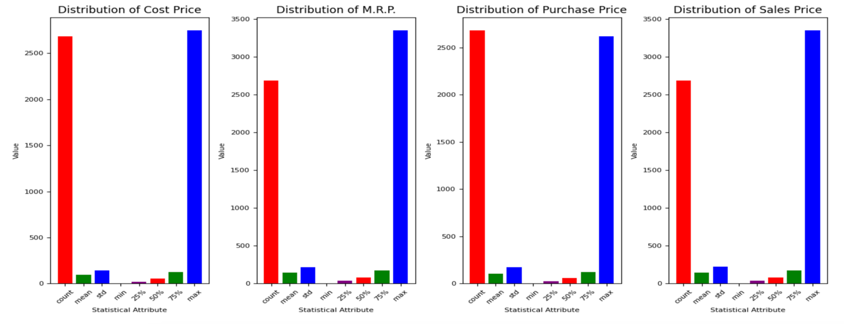

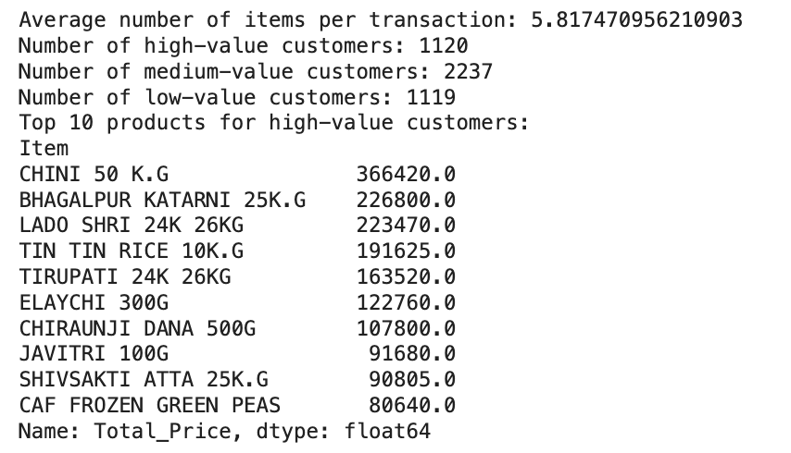

**Top Performers:**

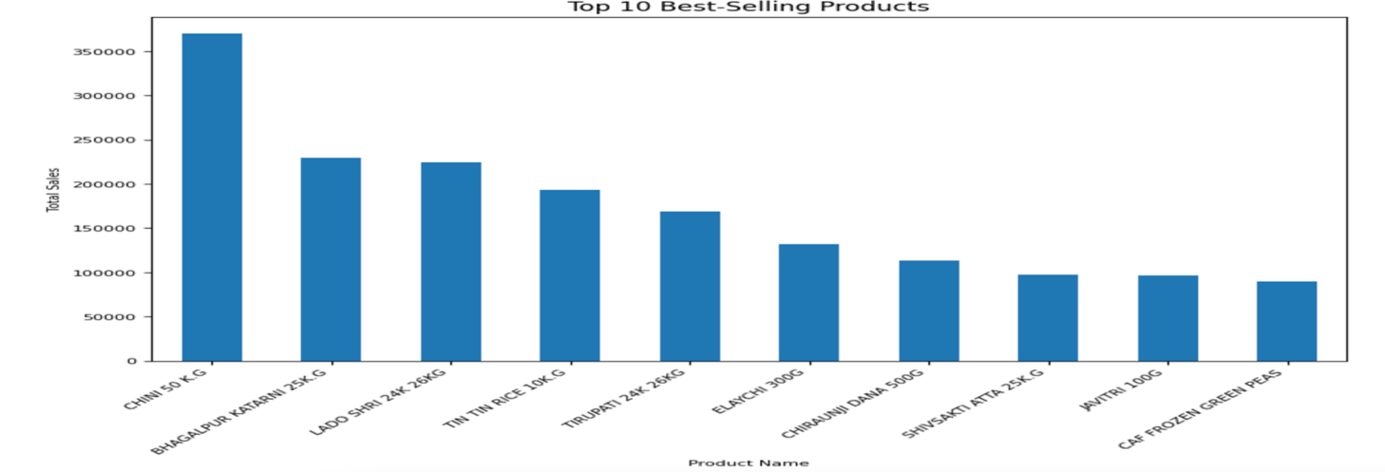

**Sales Trends:**

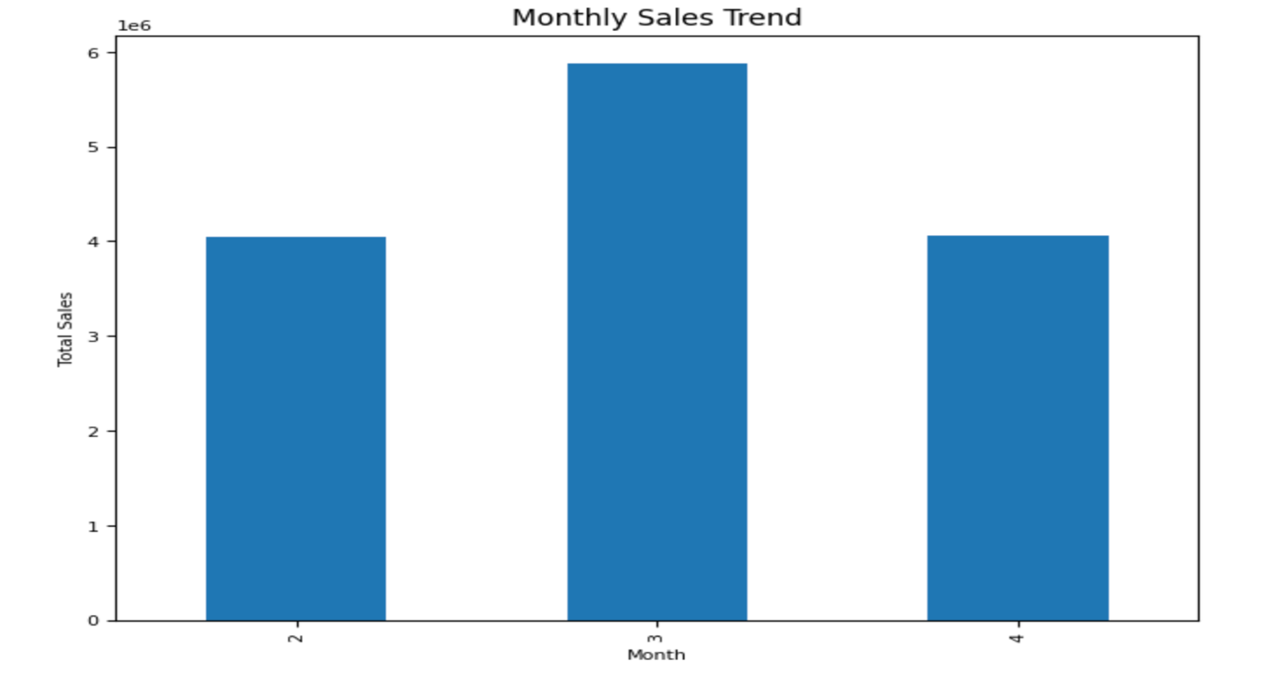

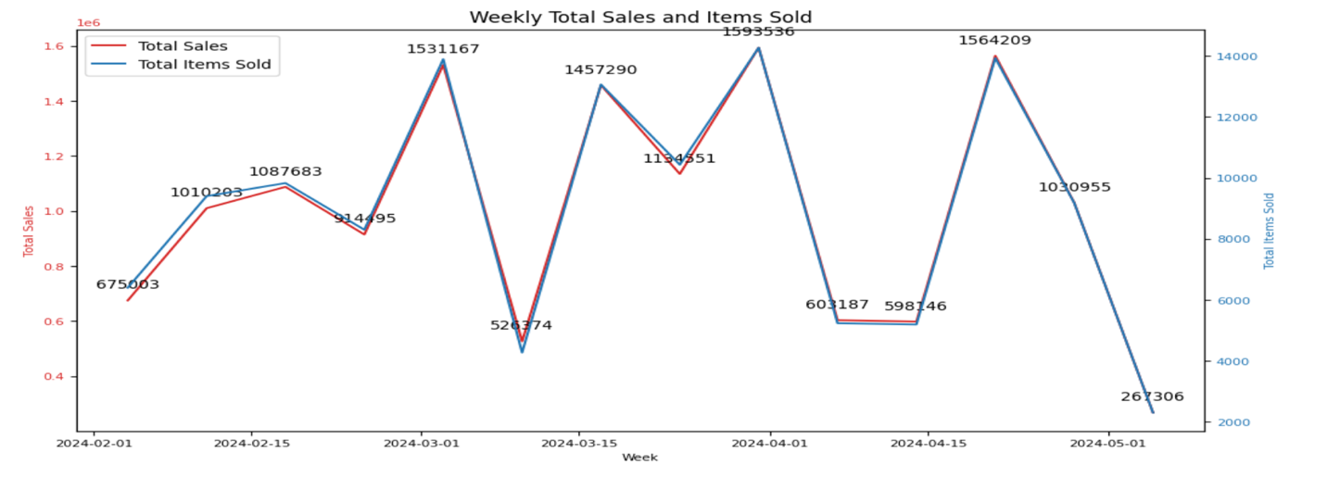

#### Market Basket Analysis

Market basket analysis delved into identifying combinations of items frequently purchased together, providing insights that can drive cross-selling and bundling strategies. Using the Apriori algorithm, association rules were generated to map co-purchased items.

**Frequent Item sets:**

* List of Top 15 pairs of items based on the number of 'Transaction_ID':

('COLD DRINKS 1.25L', 'STAR COOKIES'): 13

('BHAGALPUR KATARNI 25K.G', 'POSTA DANA 100G'): 12

('GOWARDHAN PANEER 200G', 'GO CHEESE'): 12

('SWAD ATTA 5K.G', 'TEA VALLEY GOLD 250G'): 12

('CAF GREEN PEAS 500G', 'TEA VALLEY GOLD 250G'): 12

('LOOSE TEA 250GM', 'RING BRAND VANILLA ESSENCES'): 12

('BADAMGIRI 500G', 'DONEX CT-1500'): 12

('CAF GREEN PEAS 500G', 'POSTA DANA 100G'): 11

('CHANA HALDIYA 1K.G', 'GOVERDHAN PANEER READY TO EAT'): 11

('CHANA HALDIYA 1K.G', 'KHARA GRAM MASALA 100G'): 11

('TEA VALLEY GOLD 250G', 'SOAP CASE 3 STAND'): 11

('CHANA HALDIYA 1K.G', 'AARAROT 100G'): 11

('DONEX CT-1600', 'CREAM BELL KESAR BADAM 200ML'): 11

('CAF GREEN PEAS 500G', 'AJANTA ORANGE RED FOOD COLOUR'): 11

('KHARA GRAM MASALA 100G', 'CHINI 50 K.G'): 11

#### Profitability Analysis

Profitability analysis was focused on evaluating each product’s contribution to Alpha Mart’s overall profit margins. By comparing cost price, sales price, and discounts, insights into product-level profitability were generated.

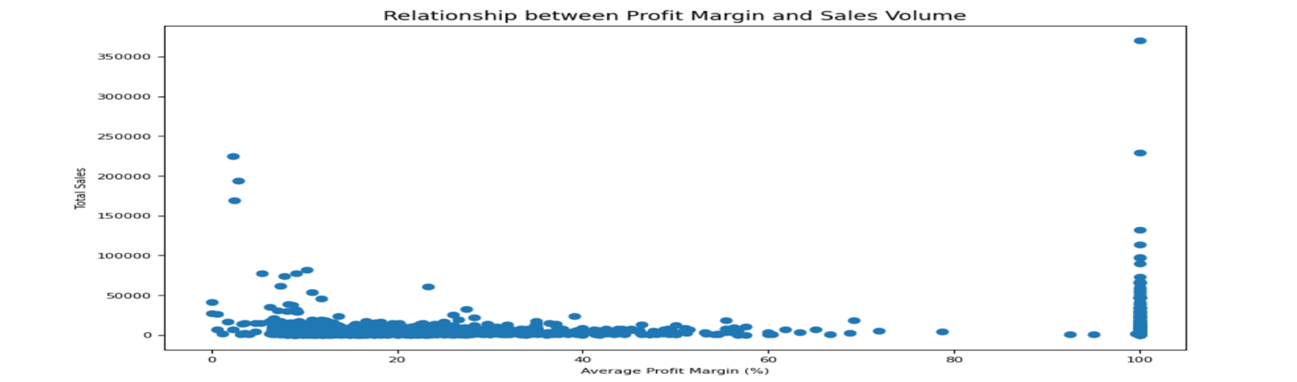

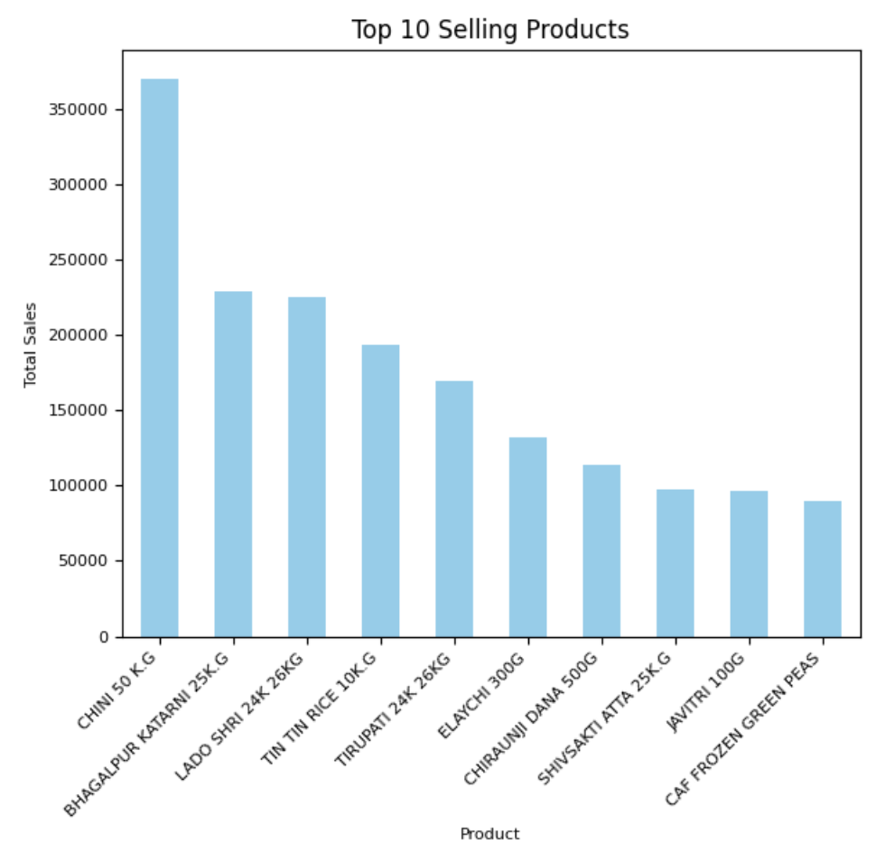

**High-Margin Products:**

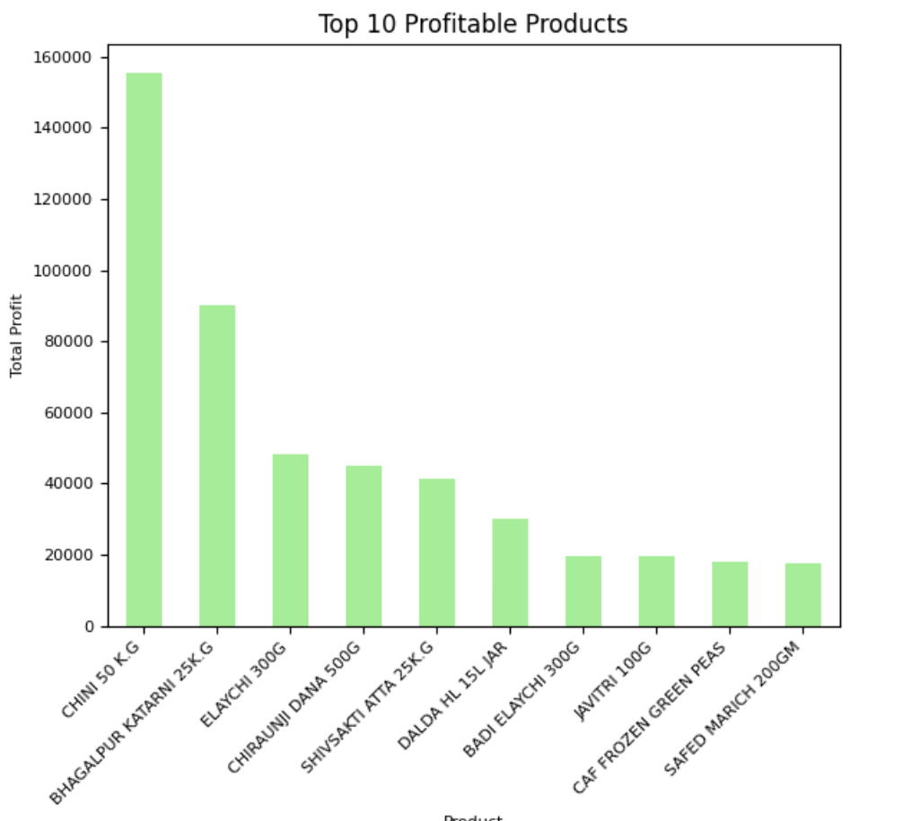

**Underperforming Products:**

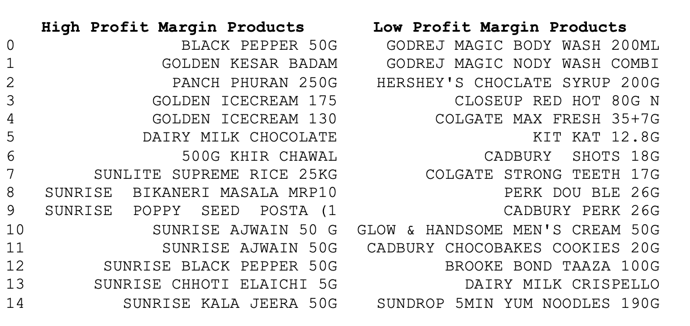

**SELF Branded (Brand: ALPHA MART) Items:**

Items under brand-name of “Alpha-mart” (in their billing system – company name is coming as -BLANK-). There are number of products from Godrej or Himalaya. But their margins are limited and dependent on wholesaler supplying them.

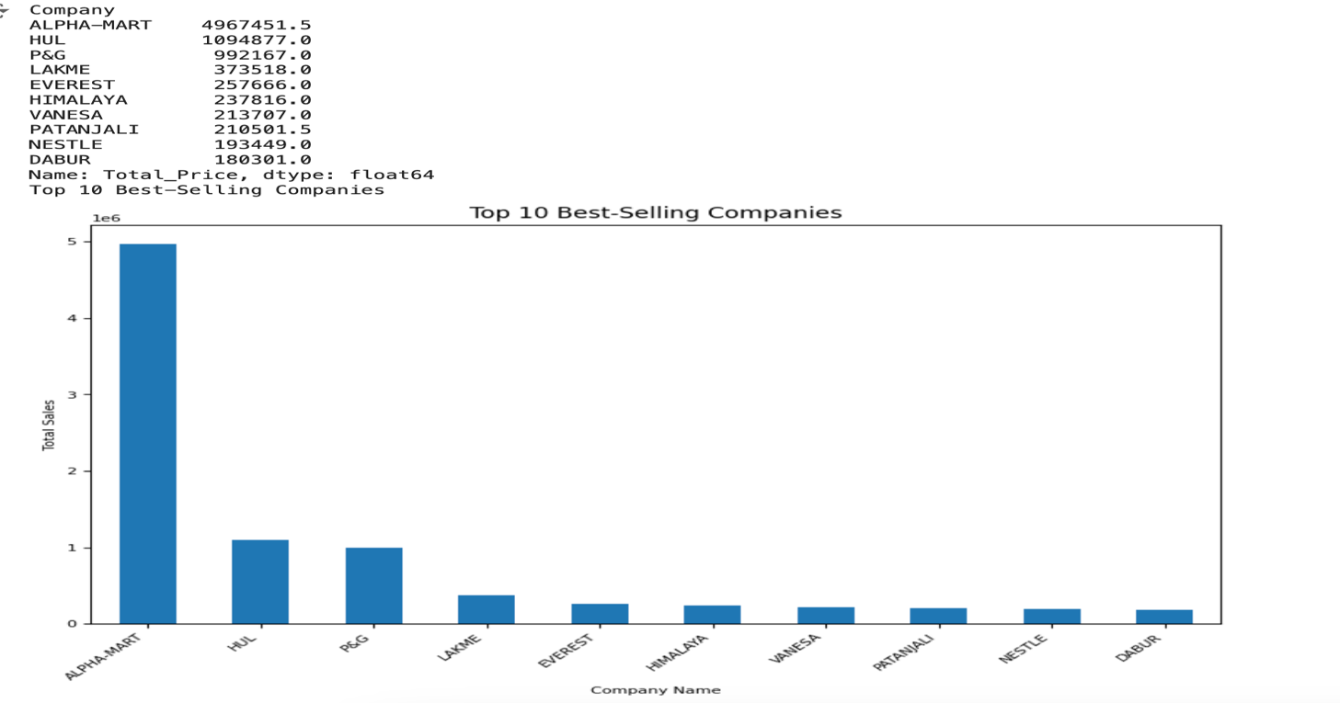

#### Customer Segmentation

Customer segmentation helped Alpha Mart divide its customer base into distinct groups based on their purchasing behaviour, frequency of purchases, and average basket size.

**Segmentation Insights:**

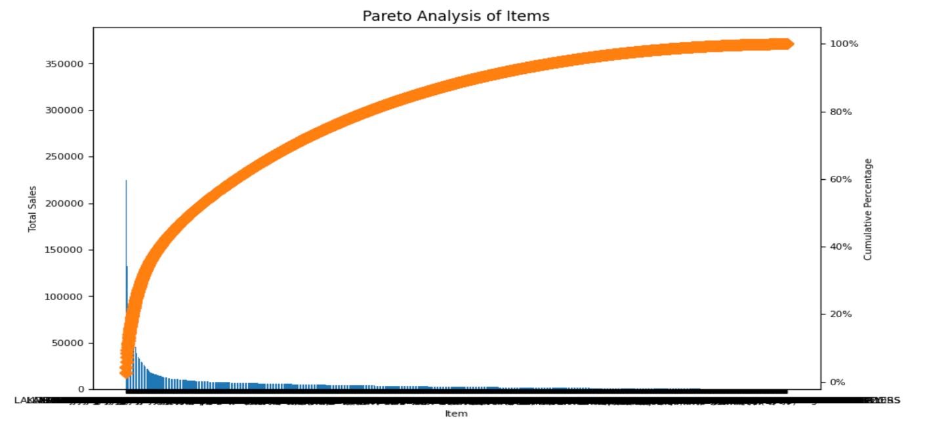

## Results and Findings

This project delivers comprehensive insights to guide Alpha Mart's path forward. Key findings and recommendations are summarized below.

**SELF Branded (Brand: ALPHA MART) Items:**

There are number of products from Godrej or Himalaya. But their margins are limited and dependent on wholesaler supplying them. However, one interesting observation was regarding most profitable brand. For some of the general staple items (like rice, sugar, Toor Dal), Alpha mart gets those items in bulk from local farmers and do the self-packaging in their warehouse. In this way, without compromising on quality, they are able to offer quite competitive pricing for many such items under brand-name of “Alpha-mart” (in their billing system – company name is coming as -BLANK-).

As **self-packaging** of staple items could provide them necessary high profit margin without compromising the quality and reputation, more items need to be included in this list of such products.

**Identification of Profitable Products and Categories**

Apart from self-branding, the analysis identified high-margin products like AJANTA BAKING POWDER 100G, GOOD DAY BISCUITS, and 500G KHIR CHAWAL, which should be prioritized. Underperforming items such as AXE SIGNATURE SUAVE and TOOR DAL 500G were flagged for adjustments. Staple food categories remain top sellers, underscoring the importance of effective inventory management.

**Customer Segmentation and Marketing Strategies**

Segmentation revealed a high-value segment (10% of customers, 40% of sales) requiring targeted marketing. Promotions and loyalty programs can engage occasional and low-frequency shoppers to drive higher basket sizes and long-term loyalty.

Through these tailored marketing strategies, Alpha Mart can enhance customer engagement and ensure long-term loyalty while driving higher basket sizes during each shopping trip.

**Association Rule Insights:**

The analysis uncovered key associations, such as the strong pairing between SHIVSAKTI ATTA 25KG and CHIRAUNJI DANA 500G, with a lift value above 1.2. This relationship not only reflects customer behaviour but also indicates that promoting these products together through discounts or bundled promotions could be a highly effective strategy. Offering a 5-10% discount on complementary goods can further incentivize customers to buy both, increasing the basket size and total revenue.

**Strategic Recommendations for Business Expansion**

The findings provide a foundation for increasing net profit margin and thus adding to Alpha Mart's expansion plans, leveraging insights from profitability, pricing, customer behaviour.

The comprehensive report provides a detailed roadmap for implementing these strategies. Key recommendations include:

* Focusing on high-margin products for inventory prioritization and stocking (listed top 15 products with high margin)
* Include more staple, non-perishable items to the list of self-packaged items under brand name of ‘Alpha mart’ and earn high profit.
* Need to maintain high inventory for most selling items to maintain continuity and influx of customer, getting more revenue due to multiplier effect.
* Targeted promotional strategy for high margin products.

**Conclusion**

In conclusion, this project has provided Alpha Mart with a robust framework for making informed, data-driven decisions that will support the store’s expansion goals. By optimizing inventory management for most selling products, adding more of self-branded & packaged (“Alpha Mart”) to gain more profit margin, and other highlighted insights, Alpha Mart is poised to achieve its vision of growth. The detailed recommendations and strategic insights derived from this analysis will serve as the blueprint for the store’s success, ensuring that it remains competitive in an increasingly challenging market environment.